**JUNIT TESTING TO CHECK WHETHER THE GIVEN STRING IS PRINTED OR NOT**

**AIM**

To Use Junit Testing Check whether the given string is printed or not.

**PROGRAM**

package sse;

public class junit1 {

public static void main(String[] args) {

// TODO Auto-generated method stub

System.out.println("hai");

}

}

**OUTPUT**

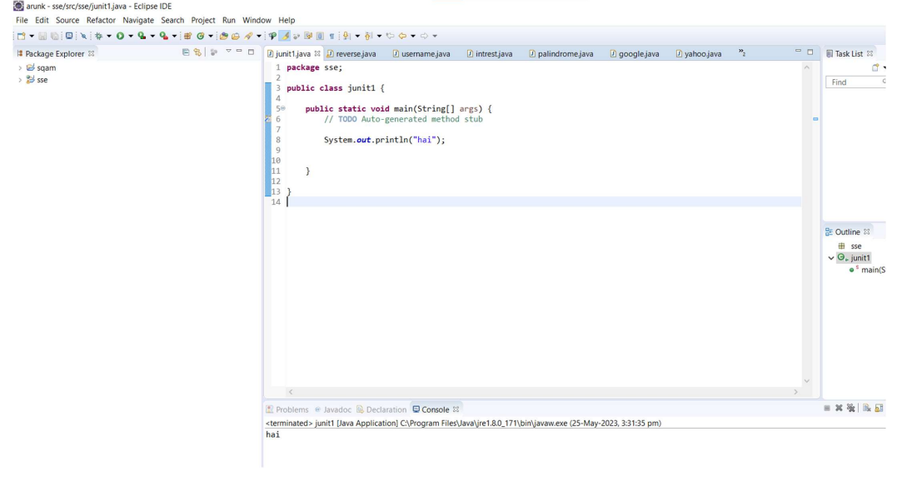

**RESULT**

Hence the Junit Testing to Check whether the given string is printed or not is executed successfully